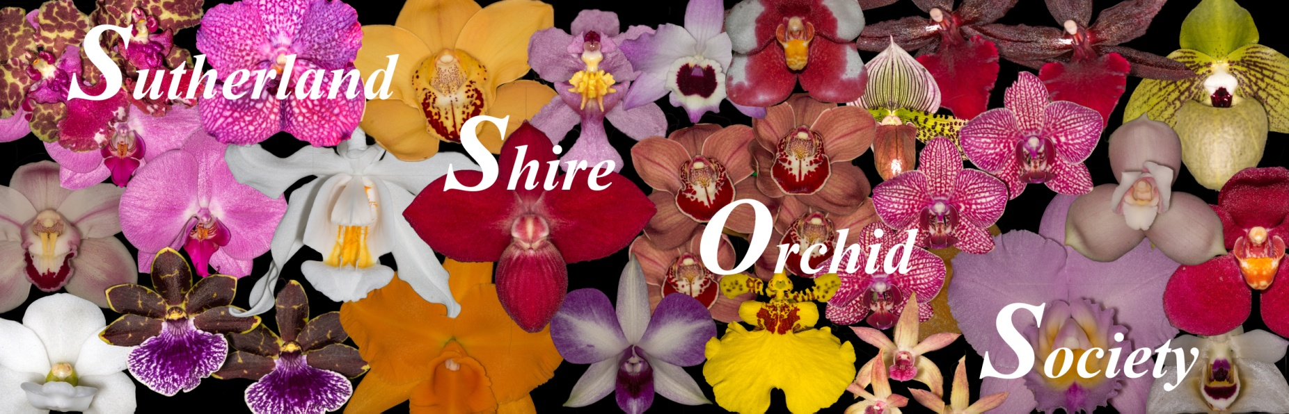
December 2018 Bulletin
Next Meeting: December 10th
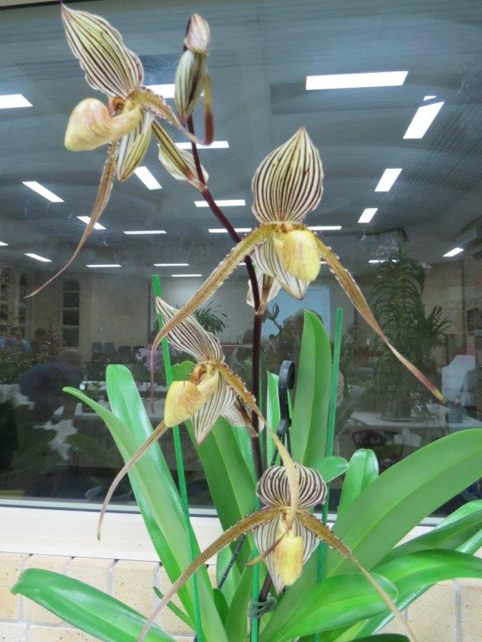
November’s Best

Paph St. Swithin 'Jacob'
Plant of the Night & Best Hybrid
Owned and grown by S.T. Ho
See ‘SSOS November Results’ for plant and grower names of other prize-winning orchids for November.
---------------------------------------------------------------------------------------------------------------------------------------------
SSOS GENERAL MEETING MINUTES - 12 November 2018
Jan Robinson extended a welcome to our members and guest speaker Greg Bourke (son-in-law of our member Ann Leer), Jan's cousin from Colorado, Rhonda Pighetti, Kim Chau and O. Crompton. Apologies were received from Tony and Pat Dos Santos and Graeme Davies. Minutes of the October meeting printed in the November bulletin were accepted as accurate.
Correspondence in: Newsletters from Orchid societies - OSNSW Orchid News, Eastern Suburbs, Eurobodalla, North Shore, Blue Mountains & Penrith Districts, Batemans Bay and North Shore Orchid Societies; Australian Orchid Council annual reports - Balance sheet, Library report, publication report, financial engagement report for their annual financial reporting; Notice of cancellation of Revesby Workers Sarc show; Hard copy of the license under the Protected Whole Plants Sustainable Management Plan 2018-2022 received in the mail; Resignation from committee from Richard Dimon; Registration form from Batemans Bay Orchid & Foliage Society for the 2019 workshop; Notification of the OSNSW 2019 Judging Course from Ian Chalmers; Christmas party invitation for President & partner or a representative from OSNSW.
New Members: Graeme Davies, Ron Hodder and Ian Neilson, who will all be placed in Novice class.

Tonight: Greg Bourke from Blue Mountains Botanic Garden, Mount Tomah a recognised expert on Carnivorous plants presented on the various trapping mechanisms of sundew, pitcher (pit fall), snap trap and fly paper carnivorous plants. Greg advised in Sydney Nepenthes would grow well in a shade house and for tropical glasshouses, there are hybrids available. He said Dendrobium beetles are not attracted to pitcher plants. Carnivorous plants are heavy feeders and need humidity and light to produce pitchers. 30% shade is good however at 50% they will struggle. They need a well drained media which is low in nutrients and like Waterwell pots. They can survive without repotting. Our members thoroughly enjoyed Greg's presentation. The judging of growing competition occurred and Mike Hitchcock spoke to Novice members on pests and diseases.
December meeting - Xmas party, giant raffle and annual point score awards. (There will be no novice group meeting)
January meeting - Annual judging of seedling competition
February meeting - Neutrog products (TBC) & final judging of growing competition
March meeting - AGM & Seedling competition final judging
Items of Interest
Richard Dimon has resigned from the committee due to his change in employment and will be away for 2 years. This creates a casual vacancy on the committee and Richard vacated the Editor role for the newsletter. Mike Hitchcock volunteered to take on this role. Jan thanked Mike for this commitment.

Batemans Bay Orchid & Foliage Society will hold the Annual Interclub workshop on Saturday 23 and Sunday 24 March 2019 and have forwarded the Registration form. Cost is $40 for both days. Speakers are Ray Clement from Tinonee Nursery, David Gynn from Sequoia Orchids (Cymbidiums), Stephen Monkhouse (Zygopetulum) and Jeanne Dunn Passion Orchids (Dockrilias). If you are interested please let one of the Committee members know.
OSNSW will commence a new Judging/Orchid Appreciation course from Friday 15 March 2019 and will continue on the 2nd Friday of each month (except December) until 2021. Meetings will be held at Berala Community Centre 2-4 Tilba St, Berala and commence at 7:30pm and conclude at 10pm. This course is intended for all who are interested in developing their knowledge of orchids, who are keen to learn about the standards set for orchid judging and ‘what the judges are looking for’ when they award prizes at your shows. A one off payment of $50.00 should be made at the commencement of the course. If you are interested contact Ian Chalmers or Veronica Clowes for further information.
At the last meeting the financial outcome from Southern Orchid Spectacular wasn't known. We are still waiting on a final invoice however preliminary figures suggest our split will be close to $2,000. Due to the increased the hall hire costs and issues with the food van we may need to find an alternative venue. Murray spoke to members last year about the need for members to volunteer to spread the workload, and how important it is for members to support the show by attending. We have about 115 members and gave out 80 free passes to all members who were not a volunteer, vendor or on the SOS committee. Only 21 free passes were used and 22 members put plants in our display. There also were vacancies on the roster which needed to be covered. Jan asked for a show of hands from those members who felt the Society should be part of the Spectacular. The majority of members present raised their hands. Jan also asked for feedback on what members want from the show and if there was anything that could be done to improve a member's experience. If you have feedback, please provide this to a committee member.
Membership renewals are due and can be paid from the November meeting. Jan Riley has taken on the role of membership officer so please pay your fees to her. For those who wish to pay by EFT, the bank account details were included in the newsletter. If you are paying by direct debit please include your name in the reference section so the payment can be traced.
As an incentive to pay your fees in a timely manner, this year the committee will put three 12 month subscriptions to Orchid Australia in the draw from those who pay their fees by the January 2019 monthly meeting.
The Christmas party with the giant raffle and annual point score awards will be held at the December meeting, on 10 December. Each member is asked to donate a gift worth $10 to the raffle. The gift can be anything that you would like to receive, with plants, orchid supplies, wine and chocolates being popular.

George Birss will hold a growers group meeting at his house on 17 November. Heath Myers will talk on Paphs and Phrags.

We have confirmed the Society's Show dates for 2019 at Woolooware Shores Retirement Village. The dates are:
Winter - 13, 14 & 15 June 2019
Spring - 29, 30 & 31 August 2019

Recently Rhonda Jackson went through the committee meeting minutes from June 1972 to October 1981to look for details about Joe Taylor, who was awarded the marble ash tray. As she thought some of the matters discussed at the meetings were curious and interesting, she read the interesting bits from these minutes to members at the meeting.
Jan handed out two OSNSW awards to S T Ho. An Award of Merit for Paph Hsinying Malone "Toby' and a Highly Commended Certificate for Paph Toby Ho 'Ollie'.
Novice member's draw of Gordon Kay's orchids - Jim Riley and Jenny Sharpham
Growing competition: Novice/intermediate - Herbert Chan 1st and Rhonda Jackson 2nd; Open - Vic Petrovski 1st, Richard Dimon 2nd, and Michael Dimon 3rd.
Name badge draw – Frank Daniel
Lucky plants - I & I Chambers, Paul Martin & Peter Fink; Col Brandon
President's award - Diane Phillips for Paph unknown
Raffle - Pam Davies, Phil Green, Di Hannah, Sonia Tropolous, John Costa, Jenny Sharpham, Robert Nicol, Noelene Wheatley, Ian Chambers & Bo Gertner.
Thank you to Col Brandon for donating Sarcs to the raffle.

Next meeting: 10 December 2018

YOU GREW IT
Ansellia Africana – exhibited by Sandra Crosby and Tony Costa

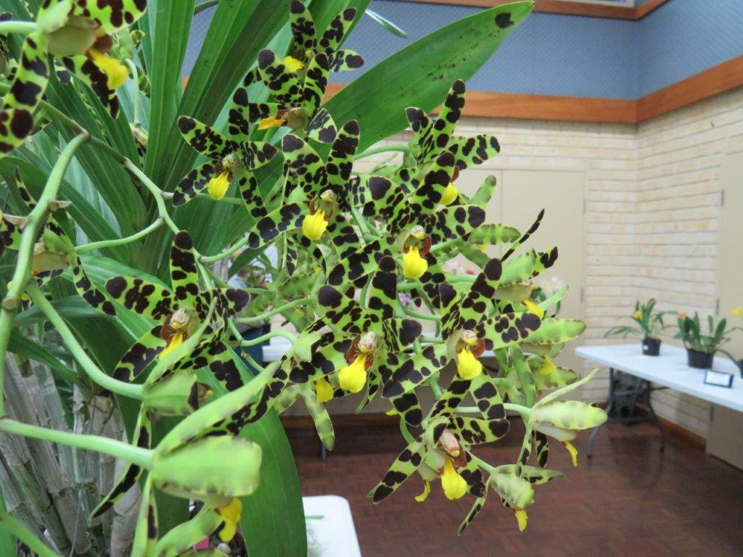
This species is a monotypic species, having only one species in that genus. It is found growing through the lower half of Africa right down to the bottom of South Africa. Found mostly along the coast or along dryish warm river areas from sea level to 700 metres it likes warm conditions. However, it has been found growing as high up as 2200 metres.
The flower colour varies from greens with brown bar markings to yellow to brown with the distinctive bar markings. I have been told that the greener varieties are found in the southern areas while the further north you travel the browner the flower.
A robust species that usually grows as an epiphyte and sometimes as a terrestrial has tall cane like pseudobulbs with 5 to 7 leaves. The inflorescence has a slightly arching habit and carries 10 to 100 highly fragrant flowers.
These orchids are usually epiphytic and are found high in the canopy of tall trees to attain maximum light to flower and also to keep them away from vegetation loving animals. Commonly found in areas with little rainfall they can go long periods without water.
Many African nations use the plant for a variety of purposes from tea making to medicinal purposes. The pseudobulbs have also been worm around the neck to prevent ex – lovers from having children.
Phaius Tankervilleae – exhibited by George Birss
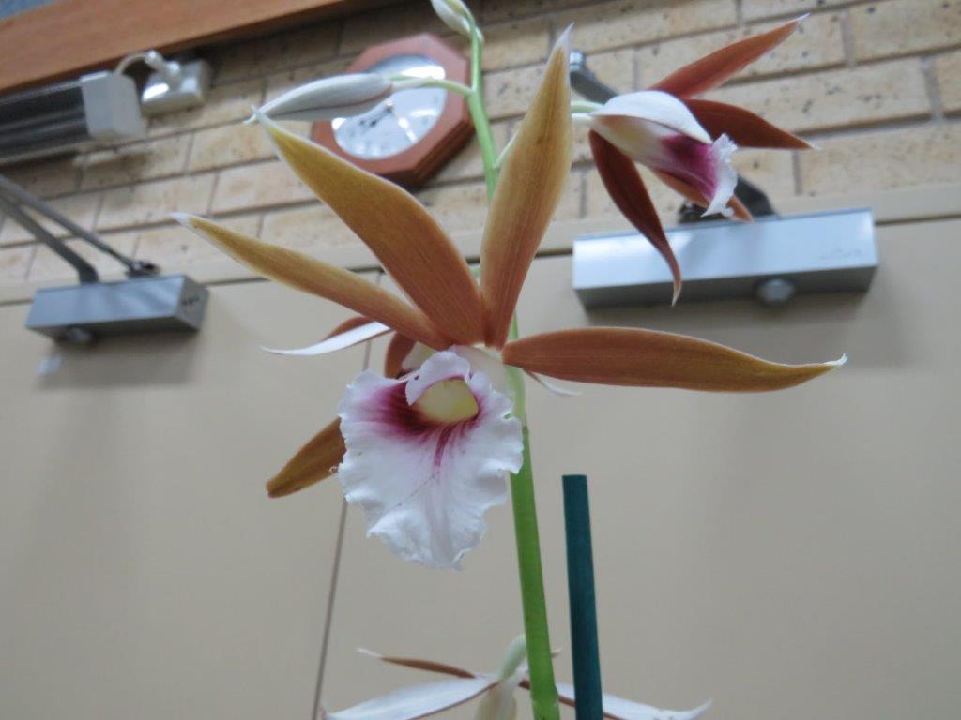
The generic name Phaius is derived from the Greek word phaios meaning dusky and was chosen because of the dark colouring of the flower. The name Tankervilleae was named after the Countess of Tankerville in 1778.
Known by many common names, such as, Nun’s Hood Orchid, Greater Swamp Orchid, Swamp Lily, Veiled Orchid and Lady Tankerville’s Swamp Orchid. It is found growing along the East Coast of Australia from Yamba to Tropical North Queensland as Phaius Tankervilleae var. Australis. It is also found in Hawaii and Florida where it was introduced. It is also found in the Sub Continent of India, China, Japan, and SE Asia to the Philippines and New Guinea.
In Australia it was usually found near river banks in damp soil or sand among Casuarina trees. It has become almost extinct in it’s natural setting due to collection and the re claiming of swamp lands. Phaius Tankervilleae is the largest native orchid found in Australia.
P. Tankervilleae can be grown in a green house in Sydney although it prefers not to go below 5 deg. Celsius. One sign of it being too cool is the tips of the leaves will become black and ragged from dying back. It requires 50% shade and to be well watered in the hot summer months. Special attention needs to be given for mealy bug and scale that like the broad thin leaves.
These plants will have an expansive root system require a rich medium, they quickly become root bound so need re potting regularly. For propergation, after the flowers have finished, the flower spike can be cut off all the way to the pseudobulb and then laid down on a bed of spag or wet sand. Small shoots may soon appear along the length of the spike below where the last flower had bloomed. These can then be cut and re potted for new plants.

Dendrobium canaliculatum – exhibited by Sandra Crosby and tony Costa
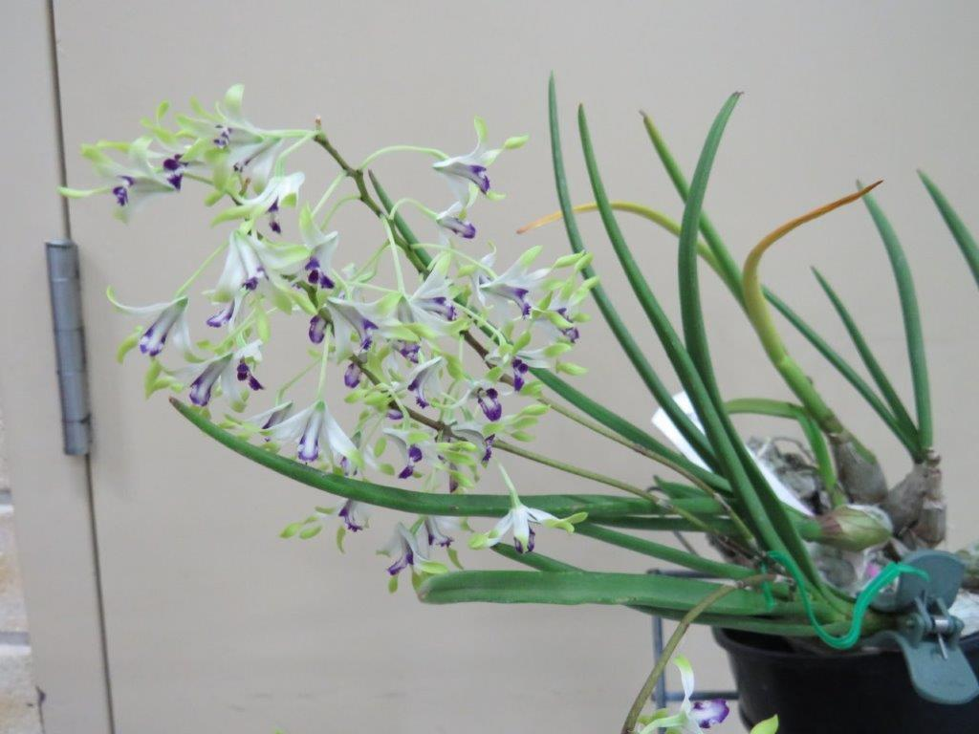

This species is commonly referred to as the Onion Orchid, the Tea tree Orchid, the Antelope Orchid or the Grooved Leaf Orchid. Originally, collected by Sir Joseph Banks, in 1770, along the Endeavour River, Queensland. Found from near Rockhampton in Northern Queensland to Cape York through the Torres Strait Islands and into New Guinea as well as Northern Territory and Northern Western Australia.
These orchids can be found growing anywhere on their host tree where their roots can burrow under the paper bark. They grow almost exclusively on Melaleuca Trees. The smallish plant has stout pseudobulbs that resemble elongated onions, hence one of the common names. These pseudobulbs can look at times dead but are more than likely just dormant and can lose all their leaves in prolonged dry periods. The leading pseudobulbs will have 2 to 4 grooved leaves that can be 2 to10 cm in length. They are found from sea level to 600 metres in a wide range of environments from swamp lands to the dry interiors and can stand the harshest of conditions. Good fresh air is essential and temperatures not below 10 deg. C.
Colour varies from white with yellow ends on the petals and sepals with a purple lip, (this is D. Canaliculatum var tattonianum - my favourite), to brown petals and sepals with a deep purple lip, to all yellow with a white lip and red spots to tangerine / orange and one I have heard of around a lake north of Cairns that is all a pale purple with a maroon lip. The flower has twisted sepals and petals.
I have had limited success with these orchids, I have maybe a dozen and they are alive and can get some to flower but other growers I know can achieve some great blooms. These are best mounted to allow the roots to dry out. Some heat is required as they come from the tropics where monsoonal conditions are the norm. In winter watering and fertilising should be reduced dramatically.
A wonderful small orchid that gives a great display, if you can achieve the right conditions.

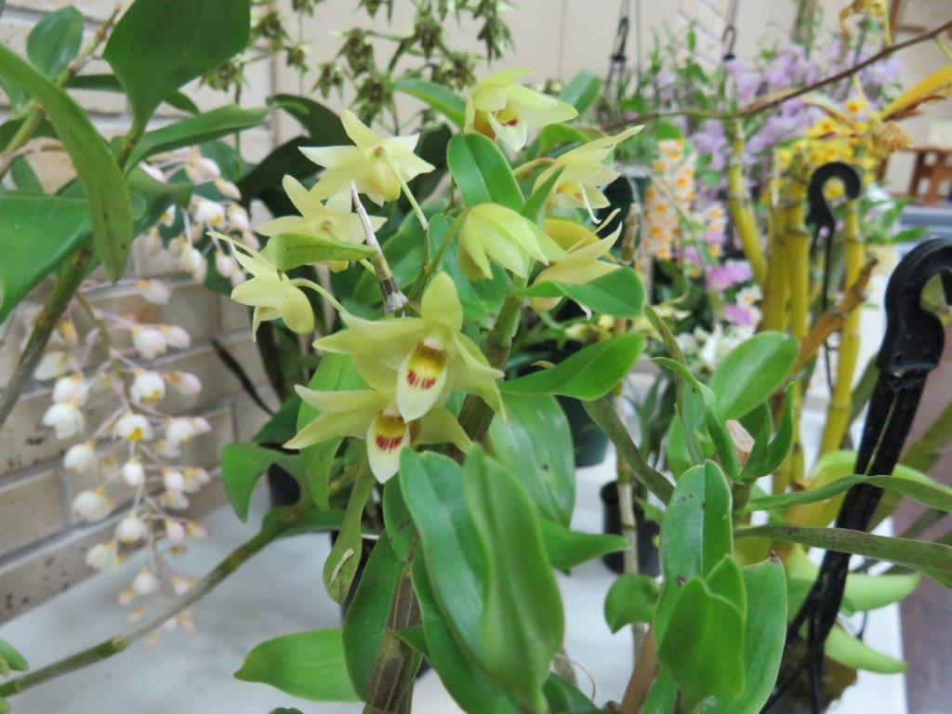

Polystachya pubescens – exhibited by Rhonda Jackson
A small sized epiphyte, sometimes lithophytes from South Africa, Swaziland and Transvaal that grows in leaf litter between exposed sandstone slabs.
This orchid grows in small clustered, clumps at elevations up to 1500 metres so will grow cold around Sydney. The conical, pyriform (pear shaped) pseudobulbs have 2 to 3 leaves and only reaches a height of 10 to 16 cms. The inflorescence can be up to 20cm in length and carry 7 to 12 successively opening flowers that can last over several months. The butter cup yellow flowers have red stripped markings on some sepals and are 2cm in diameter. They are inverted so that the dorsal petal is directed downwards or upside down.
These orchids need regular watering and fertilizing all year round but less in winter. They require strong air circulation and filtered light. Grow best in small pots or baskets with a well drained mix or mounted. The pseudobulbs appear to grow on top of each other.
Note: The Zulu people use this orchid as a ‘protective love charm’.
Note to Rhonda: I saw this plant at Species Club a few days after seeing your plant. The growth habit was the same as yours but their plant was a few years older. Although small in growth habit it was twice as big and had triple the flower count so as yours. As your plant grows you should have a plant that will give you a great deal of pleasure when you exhibit it.

In My Green House
Ah Rain again means I’m stuck inside just in time to write some articles for the newsletter. Since last month I had a couple of orchids flower that I was pretty pleased about and thought I’d share my enjoyment with you. Paphiopedilum charlesworthii. 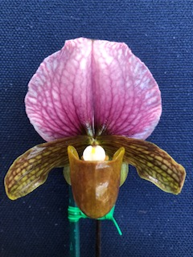
For me, a first time flowering of this orchid, and as a novice Paph. Grower I was chuffed. Over the years I have found Paphs. hard to grow, well maybe not hard to grow just hard to keep alive and those I manage not to kill don’t want to flower.
The other plant I had in flower was Rhinerrhiza divitiflora or Raspy Root Orchid. 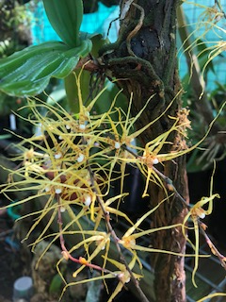
An eastern Australian species found just north of the Hunter Valley. To grow this orchid you have to give it high humidity good air movement and deep shade as much as 100%. It is very closely related to the genus Sarcochilus. It has tough leaves, long roots that have a pimply appearance. The plant can have many inflorescences per plant, one of mine had 6 inflorescences with about 12 spidery flowers per inflorescence. The down side to this wonderful little orchid is the flowers only last about 3 to 4 days so you have to be very lucky to find in flower (I hide mine amongst other mounted orchids) and even luckier to be able to take to a Society meeting. They like to be mounted and left alone and the long roots, up towards 1 metre attach to the host wood. My plant is on an old bit of branch and unfortunately loosing it’s bark so soon I’m going to have to attempt a transplant.
Well after the recent “Growers Group meeting” I got enthused to do some re potting. First job Masdevallia and a couple of Draculas. With their very fine roots and most are potted in sphagnam moss this was a very time consuming job, trying to remove the tangle of sphag.., without damaging their fine roots. Well I’ve done about 60 with either sphag. or fine bark and double potted them all. A job well done, but alas, guess what, I’ve found about another 30 tucked away. But on these wonderful little plants I have a number in spike or flower. One is Masdevallia floribunda a cute miniature tubular flower and the plant has 6 spikes with more on the way. I also have a Dracula with 5 spikes and possibly more, this one is Dracula Vampira ‘Gold’, should be interesting. I am watching these like a hawk for those little green grubs that can munch a flower spike in minutes, how they find the spike beats me. I am sure they are about, they devastated my mint bush in one day, and thank god the mint is nowhere near my orchids.
Also re potted was my two only Catasetums. Purchased at the Conference and still alive. Well getting them out of the 80mm pots was a task in its self. They were packed solid. Not sure how the roots grew. It took me about 45 minutes to get the old sphag.. Out from the root ball, but now they are in fresh mix in Waterwell pots and looking great, just got to keep alive.
I also re potted two Maxillarias, this time securing a piece of tree fern in the pot so the plants can use this as a climbing mount. They now look like somebody cares about them.
About March of this year I visited a mate who grows Stanhopea orchids and listened intently to how he had changed his growing techniques. He grows under 80% shade, grows in sphag and waters every day in spring and summer and fertilises every third day. I have changed but not to his extremes, I lowered my plants away from the direct light, probably around 60% shade, all the new leaves are green and healthy, no burnt ends and brown spots. Water, about every third day. Not in sphag.. And fertilize weekly. Plants are looking great and very healthy, hope they flower.
In the hot house I have thinned a few things out allowing more air movement. I have Bulbophylum lobbii in spike and a few other Bulbos. That looks like they are on the way. I have Ascocentrum garayi in spike, a cute little vandacious plant where the flower spike is only about 3cm high with 30 flowers. This sits in a small basket with no medium and does just fine. Oncidium pumillum the very smallest of the Oncidium alliance. The plant is 3cm high, mounted and has a flower spike about 3cm high, small and spectacular. A bigger plant is Aerides houlettianum which has a 40cm inflorescence and has about 40 to 50 buds and when open will be covered in the most brilliant yellow flowers. A disappointment is Aerangis ellisii, it was going great with about 20 flowers, but I was away for 5 days last week with the hot days. Heat and cold and no water results in buds aborting, now only about 6 flowers, I’ll enjoy these for myself but not showable. ( Read about this problem in an article in this newsletter).
In the green house Dendrobiums are putting on a good show even if some are on the miniature side. Dendrobium officinale (in bud should be right for Monday showing), very small little yellow flowers that come from China. Dendrobium stricklandianum, big name again little flower, pretty green flower with a maroon lip. Both of these are only about 1.5cm across.
For a bright colour you just can’t beat Dendrobium Gowan’s Tangello. This is a cross by Phil Spence of D. Mohlianum X D. Melinanthum and the plant is a bit straggly but has small bunches of vivid orange flowers spread along it’s branches. Definitely brightens a green house.
To add to the colour are the Indian dendrobiums, D.farmarii, D. Mousmee, D. Fimbriatum, D densiflorum & D. Thysiflorum and all the crosses that throw yellows, whites and mauves around the shade house in big bunches of flowers, unfortunately flowering for these is only about a week and you have to be lucky to get them to a show but truly spectacular to bring inside and admire.
After last month’s disaster for me with snails I am happy to report no problems so far but I have had plenty of fun squishing those outside my green house that have hidden amongst the cliviar and agapanthus. Keep vigilant for these pests and for me I’ll also be checking regularly for green grubs. Aphids, mealy bug and scale may start to appear after the rain and with a bit of warmth and humidity.
Time to go back to RE POTTING, still have plenty to do.
Looks like the rain has passed and in the one day I recorded 80mm. Nothing like rain water for your orchids and happily my water tanks are full again.
NOTE: The comments and opinions contained in this article although researched from various sources and from growing experience are those of the writer George Birss and are not those of the SSOS committee.
WHY DON’T MY ORCHIDS FLOWER
There are any number of reasons your plants won’t flower for you and one is not that they don’t like you.
Firstly your plant needs to be healthy, although many plants if neglected badly think they are going to die so want to reproduce or flower before the die. Unfortunately the flower is not at it’s best and even though you have a flower you will probably lose the plant.
Orchids need a good fresh free flowing medium, good air movement, carbon dioxide, ample water and light, depending on the genus of Orchid weather the light should be heavy shade to bright sunlight or a % of light.
Transplanted or Re Potted
Many growers are not sure when to Re pot or divide. Rule of thumb is when the plant starts new growth usually after they have flowered but despite their reputation orchids are tough. Your orchid will tell you when to re pot. Well it won’t exactly speak to you, if it does you have something special, but it will give you some hints. When the roots overflow the pot, when the plant itself is growing over the edge of the pot, when the potting mix is out dated, doesn’t drain and is soggy.
When you re pot often the roots are damaged, which causes stress to your orchid this will reduce the roots ability to supply water to the buds. But in saying this after the flower is fully formed and open re potting does little damage.
Many orchids will reproduce roots rapidly and therefore roots can be savagely attacked, Speciosum is a great example.
Over watering in Winter months
There are a large number of orchids that require a “DRY WINTER” of up to several weeks and months. This is the case with Indian Dendrobiums, Catasetums and many of the native orchids and replicates their monsoonal type growing conditions in the wild. The dry period triggers the flower buds to form. When the spring rains come this signals the bubs to swell and produce flowers. Read up on where your orchids originate and whether they have a dry period or not. For some, a rest or dry winter is essential.
Not enough water
When sufficient water is not available to the developing bud it will not fully develop and will shrivel and drop. Plants need regular watering so the flower bud cells will swell. Cold water can also have an effect and cause the buds to drop before they open.
Watering is the most basic of tasks in growing orchids and probably the most relaxing.
Orchid growers are often reluctant to water and think they will kill the orchids with kindness; in general they don’t water enough.
It is important that the root system is allowed to drain freely and quickly and there is a constant movement of fresh air.
Misters will increase the humidity and cool the temperature around the plant. Deep watering where water runs out the drainage holes is essential not only for the orchid but to wash away excess salts and Fertiliser.
Temperature differences between day and night.
One of the most common reasons orchids don’t flower is that they don’t get a temperature drop between the day temperature and the night temperature, this is very common where orchids are grown indoors where the temperature variation is only a few degrees due to heaters and air conditioners.
In the orchids natural habitat night or evening temperatures vary by 10 to 15 degrees to those in the day. This drop or change initiates the orchid to develop flowers.
I have heard some stories, although I haven’t tried them. Whether they are true or just “old wives tales” I’ll let you decide:
Cymbidium growers water their plants with ice water in the evenings for a week at the end of February to fool the plant into thinking winter is on the way and the plant will initiate flower spikes – myth or not ?.A Phalaenopsis grower from down the Shoalhaven area turns off the heating in his Phally house, opens the door and allows the temperature to drop for a few days then re heats. He does this 90 days prior to their show and had Grand Champion with that same Phally three years in a row – myth or not ? TRUE !!!!
High and Low Temperatures
Excessive High and or low temperatures can have a detrimental effect on your flower buds as they start to develop and they may shrivel and drop off. Unfortunately flower buds are very vulnerable to stress.
If orchids are exposed to colder conditions or sudden cold snaps this will slow down the growth and this can also cause the buds to drop. On the other side of the temperature scale if extreme hot weather develops your orchids will slow or stop their growth and the bubs will wilt before they open. A short burst of higher than normal temperatures shouldn’t be too harmful providing the humidity stays high.
Low humidity
Humidity in your growing area should be at least 60% or higher. If the air is too dry when the buds are forming they will sometimes dry up before opening, bud blast. Insufficient humidity can also stunt an orchid’s growth and can be a cause of brown tips on the leaves or leaves wrinkling.
Not enough light
If your orchids leaves are a very dark green or the new growth is longer than previous growth or if the new leaves are further apart on the stem these are all signs that your orchid is not getting enough light. Your orchid will survive and look really healthy and keep growing BUT it won’t flower.
I have seen orchids that were growing great, plenty of new foliage but no flowers. I have moved the orchid only 30cm but where it received more light and hey presto, flowers.
Fertilisers –with too much Nitrogen
The bark mixes we use have no nutrients. Orchids have very low nutrient needs but need some type of Fertiliser to grow.
Fertilisers come in two categories – organic (natural) and inorganic (chemical). These Fertilisers have primary elements for plant growth. Nitrogen (N), Phosphorus (P) and Potassium (K) defined as the NPK of the Fertiliser. There are also secondary or trace elements included such as calcium, magnesium, sulphur, boron, manganese, zinc, copper and iron but these are only in minute quantities.
Applying Fertilisers with a high Nitrogen percentage produces lush leaf growth with poor or no flowers.
Fertilisers boost and help an already healthy orchid to grow. Fertilisers are not a magic elixir to save the day and can be harmful for an orchid in poor health. Fertilisers are not a food for your orchid. Orchids produce their own food through sunlight, water and carbon dioxide. Fertilisers provide minerals that the orchid needs to make photosynthesis more efficient.
Immature plants
Buying a seedling or an immature plant you may wait a year or two or sometimes ten before you get flowers. If the plant isn’t in flower when purchased it may not have matured enough to flower. Some varieties take several years to mature, some as many as ten years and more. Be patient, wait, enjoy growing you orchid to see the reward when it does flower.
Some growers, particularly Paph growers will let a young plant flower for the first time, just to see what the flower looks like and then cut off the flower spike to allow the plant to strengthen and produce another growth thus putting the goodness back to the plant and not the flower. Usually the second or third flowering the flower is bigger and better than the first and the plant is stronger and less likely to die if they had left the first flower to such all the energy to the flower and not the plant. That is when the Paph grower will decide whether to keep the plant as a possible Grand Champion or sell it as a nice flower.
Gardeners have been using this practice for years, de budding plants, taking the first 6 to 10 flowers off petunias and violas to encourage the plant to grow bigger in size for future flowerings and bigger flower counts.
NOTE: The comments in this article although researched from various sources and from growing experience are those of the writer, George Birss are his opinions and not those of SSOS committee.
MONTHLY JUDGING RESULTS
For : | Nov. 2018
PLANT OF NIGHT
Winner | Paph. St. Swithin 'Jacob' |  | S. T. Ho
OPEN CLASS HYBRID
Winner | Paph. St. Swithin 'Jacob' |  | S. T. Ho
OPEN CLASS SPECIES
Winner | C. coccinea |  | J. Robinson
INTERMEDIATE JUDGES CHOICE
Winner | Den. chrysotoxum |  | H. Chen
NOVICE & JUNIOR JUDGES CHOICE
Winner | Cym. Cricket |  | F. Daniel
PRESIDENT'S CHOICE
Winner | Phal. 'unknown' |  | D. Phillips
CLASS # 1 AUSTRALIAN NATIVES
1st | Den. canaliculatum |  | S.Crosby/T.Costa
2nd | Sarco. hartmannii 'Red Snow' |  | S.Crosby/T.Costa
3rd | Sarco. hartmannii 'Red Centre' |  | S.Crosby/T.Costa
4th | Den. lichenastrum |  | G. Birss
CLASS # 2 PAPHIOPEDILUMS SPECIES
1st | Paph. philippinense |  | S. T. Ho
2nd | Paph. delenatii |  | J. Robinson
3rd | Paph. hirsutissimum |  | J. Robinson
4th | Paph. urbanianum |  | S.Crosby/T.Costa
CLASS # 3 LAELIINAE OVER 110MM (CLASSICAL SHAPE)
1st | Blc. Mount Isa 'Jean' |  | W. McEvoy
2nd | Blc. Sylvia Fry 'Olga' |  | T. Hyde
3rd | C. Only You |  | W. McEvoy
4th | Cat. 'unknown' |  | V. Petrovski
CLASS # 4 NOVELTY PAPHIOPEDILUMS
1st | Paph. St. Swithin 'Jacob' |  | S. T. Ho
CLASS # 5 LAELIINAE OVER 80MM UP TO & INCLUDING 110MM (CLASSICAL SHAPE)
1st | Lc. Aloha Case 'Ching Hua' |  | S.Crosby/T.Costa
2nd | C. Dolosa |  | W. McEvoy
3rd | C. Dolosa 'Gorgeous' |  | P. Davies
CLASS # 6 PAPHIOPEDILUM
1st | Paph. Honey Gorse 'Downland' |  | M. Dimon
2nd | Paph.Winston Churchill x Paph Hong Sheng Tiger Cat ?? |  | H. Myers
CLASS # 7 LAELIINAE (NON CLASSICAL SHAPE)
1st | Epc. Dark Fire |  | J. Costa
2nd | Lc. Elegant x C. intermedia 'alba' ?? |  | P. Davies
3rd | Lc. Momilani Rainbow |  | S.Crosby/T.Costa
4th | Sergioara Yokosuka Story |  | P. Ng
CLASS # 7a CLUSTER LAELIINAE
1st | Jackfowlieara Appleblossom |  | S.Crosby/T.Costa
2nd | Jackfowlieara Appleblossom |  | W. McEvoy
3rd | Epi. Topaz Special 'Elegante' |  | D. Phillips
CLASS # 8 LAELIINAE UP TO & INCLUDING 80MM (CLASSICAL SHAPE)
1st | Lc. Tokyo Magic'6-1' x Slc.Cosmic Delite 'SVO' |  | V. Petrovski
2nd | Lc. Dakao 'Flamea Enami' |  | P. Ng
3rd | Pot. Free Magic |  | G. Hodder
4th | Pot. Big Dream |  | S.Crosby/T.Costa
CLASS # 9 AUSTRALIAN NATIVE HYBRIDS
1st | Den. Hilda Poxon |  | S.Crosby/T.Costa
2nd | Den. Karani 'Denis' |  | C. Brandon
CLASS # 9A DENDROBIUM SPECIES EXOTIC
1st | Den. chrysotoxum |  | P. Ng
2nd | Den. regium |  | L. Buivids
3rd | Den. regium |  | J. Robinson
4th | Den. thyrsiflorum |  | J. Robinson
5th | Den. farmeri var alba |  | G. Hodder
CLASS # 10 SPECIES ASIAN (Elsewhere not Included)
1st | Mcs.ampullaceus 'Red' x 'Orange' |  | M. Dimon
2nd | Vanda tricolor var suavis |  | L. Buivids
CLASS # 10B ONCIDINAE SPECIES
1st | Bapt. echinata 'swarming bees' |  | G. Birss
CLASS # 11A COELGYNINAE SPECIES
1st | Coel. mooreana 'Brockhurst' |  | G. Birss
2nd | Pholidota chinensis |  | W. & J. Chapman
3rd | Coel. amoena?? |  | J. Costa
4th | Coel. celebensis |  | I. & I. Chalmers
CLASS # 12 SEEDLING
1st | Phal. Green Pixie |  | P. Ng
2nd | Paph. acmodontum |  | S. T. Ho
CLASS # 13 ONCIDIUM HYBRIDS 60MM AND UNDER
1st | Onc. Sydney |  | L. Buivids
2nd | Onc. Copper Scarab 'Brass Bretheren' |  | J. Costa
CLASS # 14 PHALAENOPSIS
1st | Phal. 'unknown' |  | D. Phillips
2nd | Phal. 'unknown' |  | D. Phillips
CLASS # 15 ONCIDIUM HYBRIDS OVER 60mm
1st | Ocdcm. Tiger Crow |  | S.Crosby/T.Costa
2nd | Goodaleara Pacific Truffle 'Surogate Star' |  | S.Crosby/T.Costa
3rd | Bcd. Gilded Tower 'Mystic Maze' |  | V. Petrovski
4th | Mps. Rubenesque 'Karismic Kay' |  | J. Costa
CLASS # 16 MISCELLANEOUS HYBRIDS
1st | Lyc. Strange Charm |  | S.Crosby/T.Costa
2nd | Z. Debbie De Mellow 'Honolulu Baby' |  | J. Costa
3rd | Coel. Burfordiense |  | I. & I. Chalmers
CLASS # 17 DENDROBIUM HYBRIDS
1st | Den. Hoshimusume Heart x Ruby Blossom |  | V. Petrovski
2nd | Den. Chet's Choice |  | G. Birss
3rd | Den. Gowan's Tangello |  | I. & I. Chalmers
4th | Den. Yellow Stars |  | V. Petrovski
5th | Den. Mousmee |  | R. & J. Ettrick
CLASS # 18 VANDACEOUS
1st | Rhrds. Norma 'Sweet and Vibrant' |  | S.Crosby/T.Costa
2nd | V. Robert's Delight 'Black Butterfly' |  | M. Dimon
CLASS # 19 MASDEVALLIA & DRACULA SPECIES
1st | Masd. angulata |  | G. Birss
CLASS # 21A PLEUROTHALLIDINAE HYBRIDS
1st | Masd. Charisma x Carousel |  | S.Crosby/T.Costa
2nd | Masd. El Dorado |  | S.Crosby/T.Costa
3rd | Masd. Winged Leopard |  | S.Crosby/T.Costa
4th | Masd. Gairiana 'Yellow Bird' |  | S.Crosby/T.Costa
CLASS # 21B LAELIINAE SPECIES
1st | C. coccinea |  | J. Robinson
2nd | C. mossiae semi alba |  | W. McEvoy
3rd | C. purpurata 'Keith Sissian' |  | J. Costa
4th | C. mossiae |  | L. Buivids
CLASS # 22 MINITURE CYMBIDIUMS UNDER 60mm
1st | Cym. Bicolor Canliculatum Tansey ?? |  | V. Petrovski
2nd | Cym. Sweet Devon |  | V. Petrovski
3rd | Cym. finlaysonianum x Sparkesii ?? |  | V. Petrovski
CLASS # 23 SPECIES OTHER (NOT ELSEWHERE INCLUDED)
1st | Ansellia africana |  | S.Crosby/T.Costa
2nd | Max. tenuifolia |  | P. Ng
3rd | Max. variabilis 'Black' |  | G. Birss
4th | Max. variabilis 'Gold'' |  | L. Buivids
CLASS # 23A OTHER PLEUROTHALLIDINAE SPECIES
1st | Pths. stricta |  | J. Robinson
2nd | Stellis papaquerensis |  | G. Birss
3rd | Rstp. wagneri |  | G. Birss
CLASS # 24A NATIVE SARCANTHINAE HYBRIDS
1st | Sarco. Toby 'Nev' |  | C. Brandon
2nd | Saro. Memoria Dennis Wood |  | J. Robinson
3rd | Sarco. Madge |  | P. Davies
4th | Sarco. Serenade 'Dave' |  | C. Brandon
5th | Sarco. Durras |  | C. Brandon
CLASS # 26 NOVICE - CYMBIDIUMS
1st | Cym. Cricket |  | F. Daniel
CLASS # 27 - NOVICE - NATIVE & NATIVE HYBRIDS
1st | Den. toressae |  | C. Castle
2nd | Sarco. Firebird 'On Fire' |  | M. Spring
3rd | Den. Icy Pink 'Sakura' |  | M. Spring
CLASS # 28 NOVICE - LAELIINAE
1st | Epi. Tiny Valley 'Mahine' |  | M. Spring
CLASS # 29 NOVICE - MISCELLANEOUS
1st | Phal 'unknown' |  | J. Sharpham
2nd | Phal. Baldan's Kaleidoscope "Golden Treasure' |  | J. Sharpham
3rd | Dtps. Chian Xen Mammon |  | J. Sharpham
4th | Phal. Chia-Shing Hot Kiss |  | J. Sharpham
CLASS # 30 NOVICE -SPECIES
1st | Chysis laevis |  | D. Went
2nd | Rstp. Sp ?? |  | C. Castle
CLASS # 33 INTERMEDIATE - NATIVE SPECIES & NATIVE HYBRIDS
1st | Sarco. Kunama |  | D. & M. Hannah
2nd | Sartylis Toowoomba Sparkle 'Coconut Ice' |  | D. & M. Hannah
3rd | Sarco. Peace |  | D. & M. Hannah
4th | Sarco. Toowoomba Magic |  | D. & M. Hannah
CLASS # 34 INTERMEDIATE - LAELIINAE
1st | Pot. Lo's Magic Love 'Dandy' |  | H. Chen
2nd | C. intermedia var amethystina x Lc. Aussie Sunset |  | H. Chen
3rd | Cattleya 'unknown' |  | H. Chen
CLASS # 35 INTERMEDIATE - MISCELLANEOUS
1st | Ascda. Takkirt Gold x V. Patcharee Delight ?? |  | H. Chen
CLASS # 36 INTERMEDIATE - SPECIES
1st | Den. chrysotoxum |  | H. Chen
2nd | Polystachya pubescens |  | R. Jackson
3rd | Den. hercoglossum |  | H. Chan

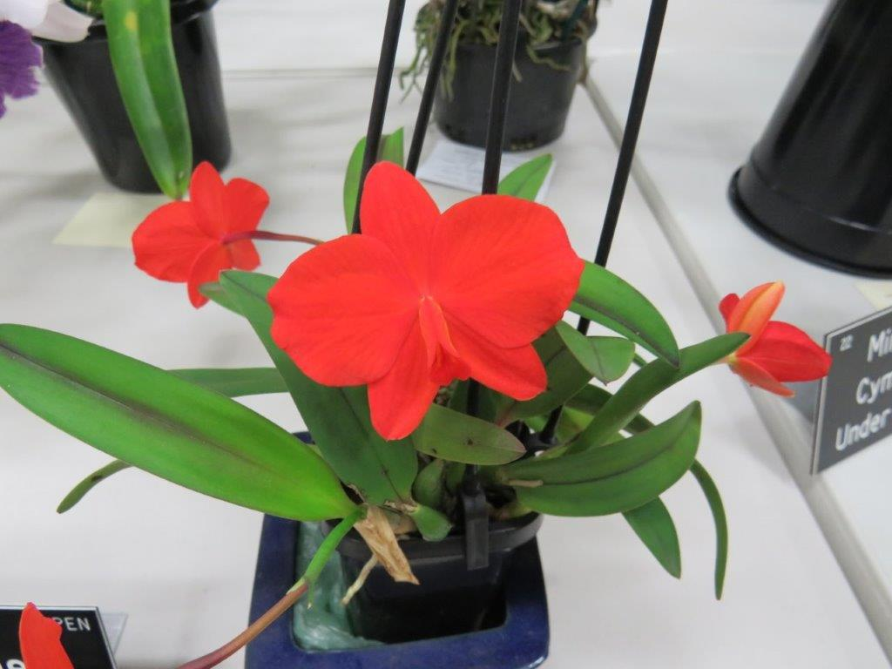
C. coccinea grown by Jan Robinson | J. Robinson

Den canaliculatum grown by Sandra Crosby & Tony Costa


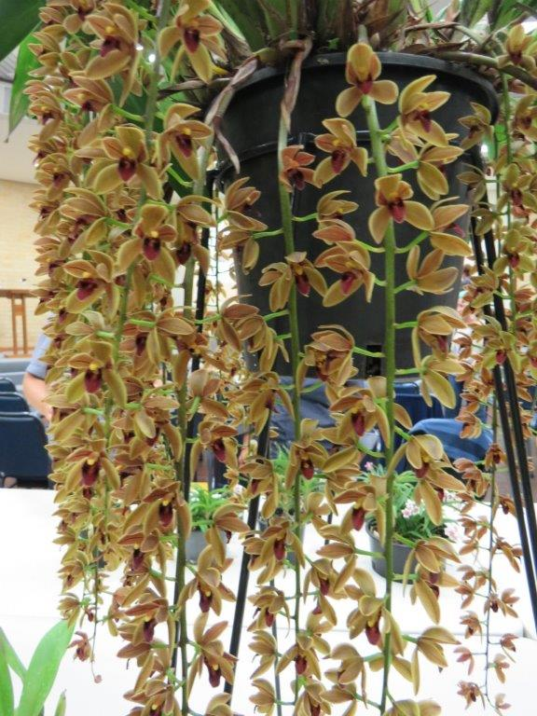
Cymbidium Cricket grown by Frank Daniel
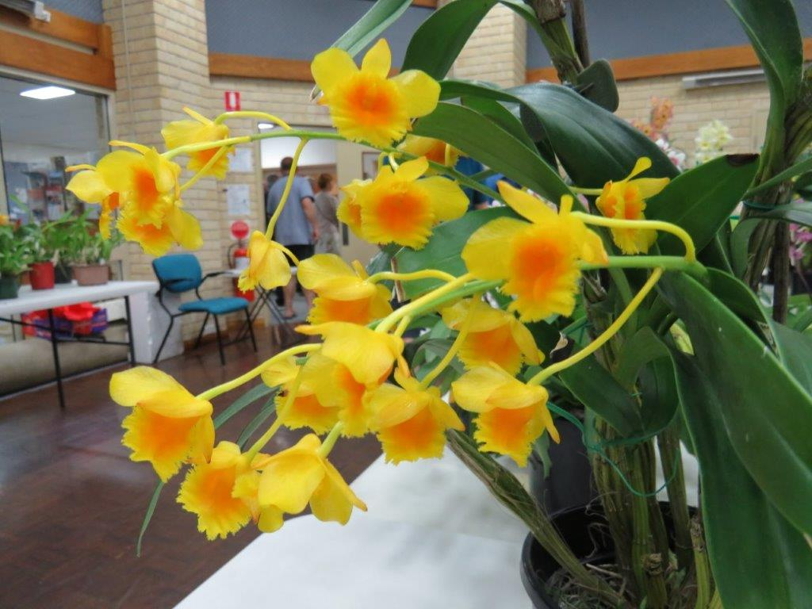
Den. Chrysotoxum grown by Frank Chen | H. Chen

